**Assignment 1**

Creating Database and Table

* Create **Northwind** Database

**Query :** CREATE DATABASE Northwind

* Create **Products** Table

**Query :**

CREATE TABLE Products

(

ProductID int NOT NULL PRIMARY KEY IDENTITY(1, 1),

ProductName varchar(50) NOT NULL DEFAULT '',

SupplierID int NOT NULL,

CategoryID tinyint NOT NULL,

QuantityPerUnit varchar(20) NOT NULL DEFAULT '',

UnitPrice decimal NOT NULL DEFAULT '0',

UnitsInStock smallint NOT NULL DEFAULT '0',

UnitsOnOrder smallint NOT NULL DEFAULT '0',

ReorderLevel smallint NOT NULL DEFAULT '0',

Discontinued bit NOT NULL DEFAULT 0

)

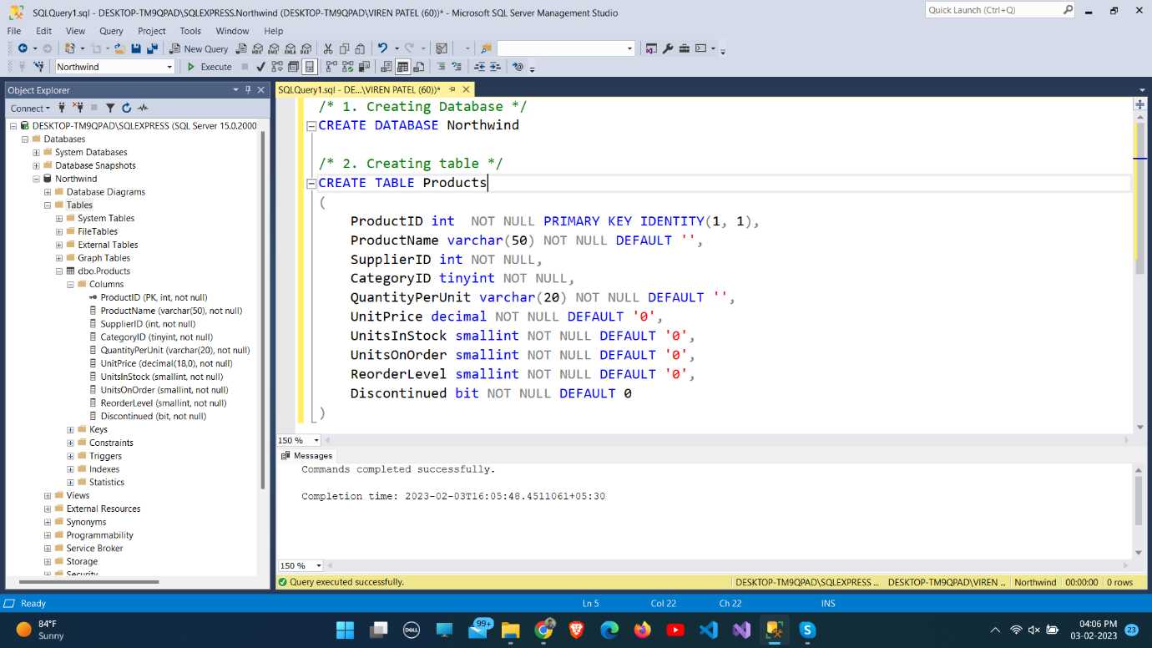

1. **Write a query to get a Product list (id, name, unit price) where current products cost less than $20.**

**Query :** SELECT ProductId, ProductName, UnitPrice FROM Northwind.dbo.Products WHERE (UnitPrice < 20) AND (Discontinued = 0)

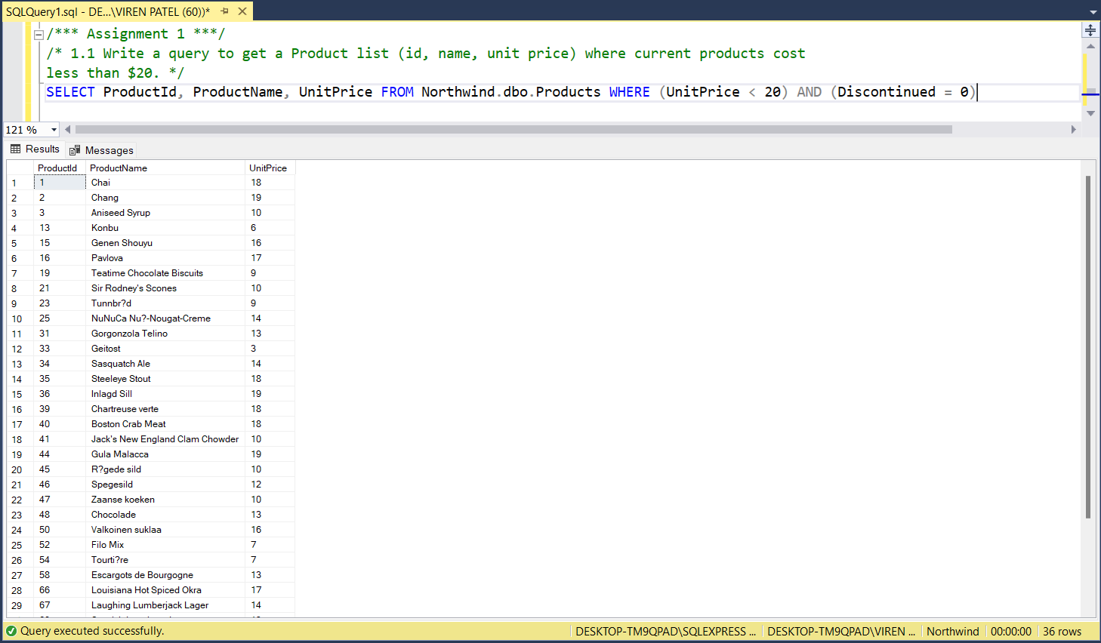

1. **Write a query to get Product list (id, name, unit price) where products cost between $15 and $25.**

**Query :** SELECT ProductId, ProductName, UnitPrice FROM Northwind.dbo.Products WHERE UnitPrice > 15 AND UnitPrice < 25

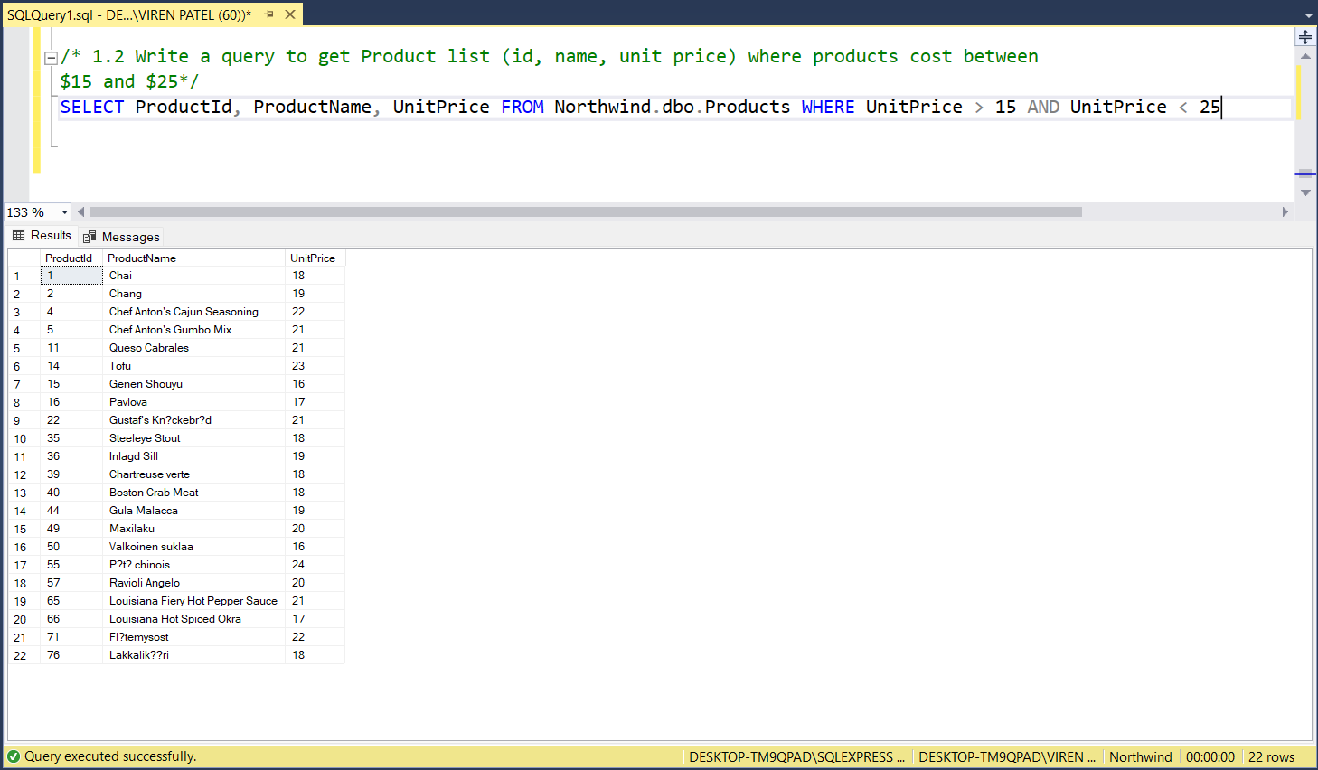

1. **Write a query to get Product list (name, unit price) of above average price.**

**Query :** SELECT ProductName, UnitPrice FROM Products WHERE UnitPrice > (SELECT AVG(UnitPrice) FROM Products)

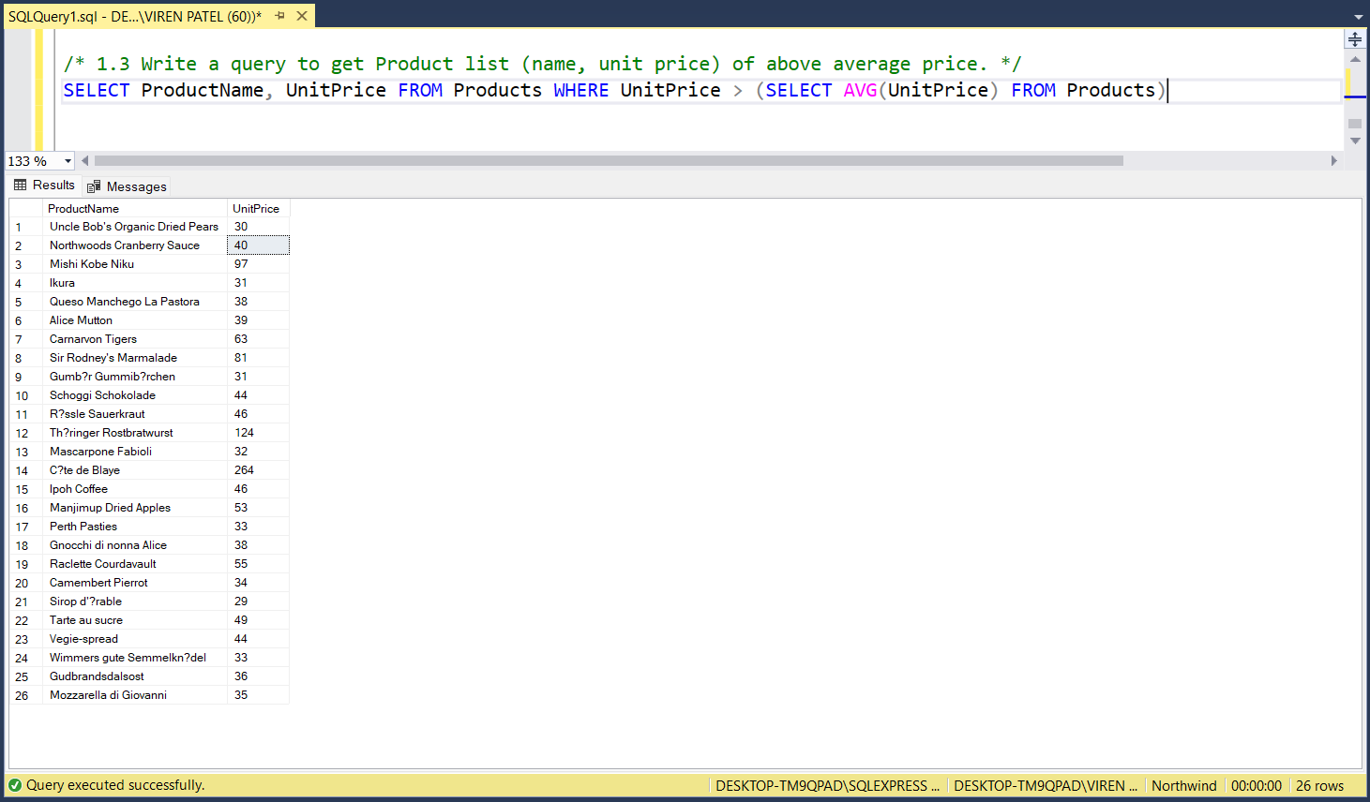

1. **Write a query to get Product list (name, unit price) of ten most expensive products.**

**Query :** SELECT TOP 10 ProductName, UnitPrice FROM Products ORDER BY UnitPrice DESC

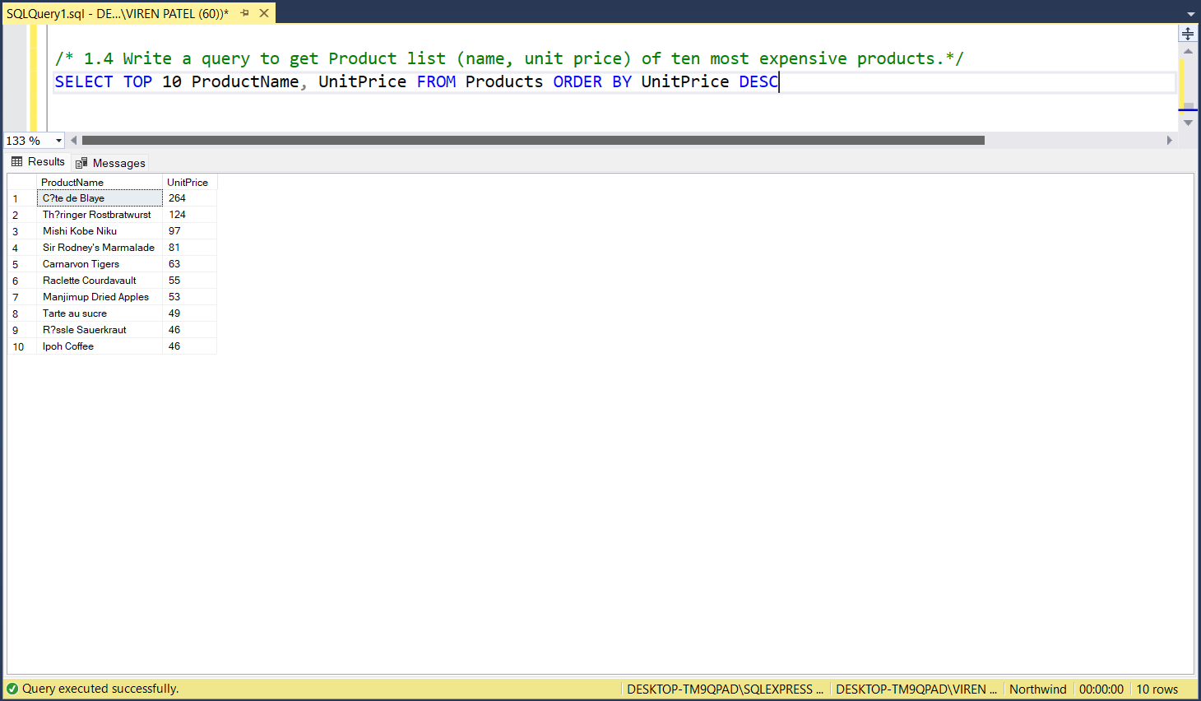

1. **Write a query to count current and discontinued products.**

**Query :**

/* Count Current Products */

SELECT COUNT(Discontinued) AS CurrentProducts FROM Products GROUP BY Discontinued

HAVING Discontinued=0

/* Count Discontinued Products */

SELECT COUNT(Discontinued) AS DiscontinuedProducts FROM Products GROUP BY Discontinued HAVING Discontinued=1

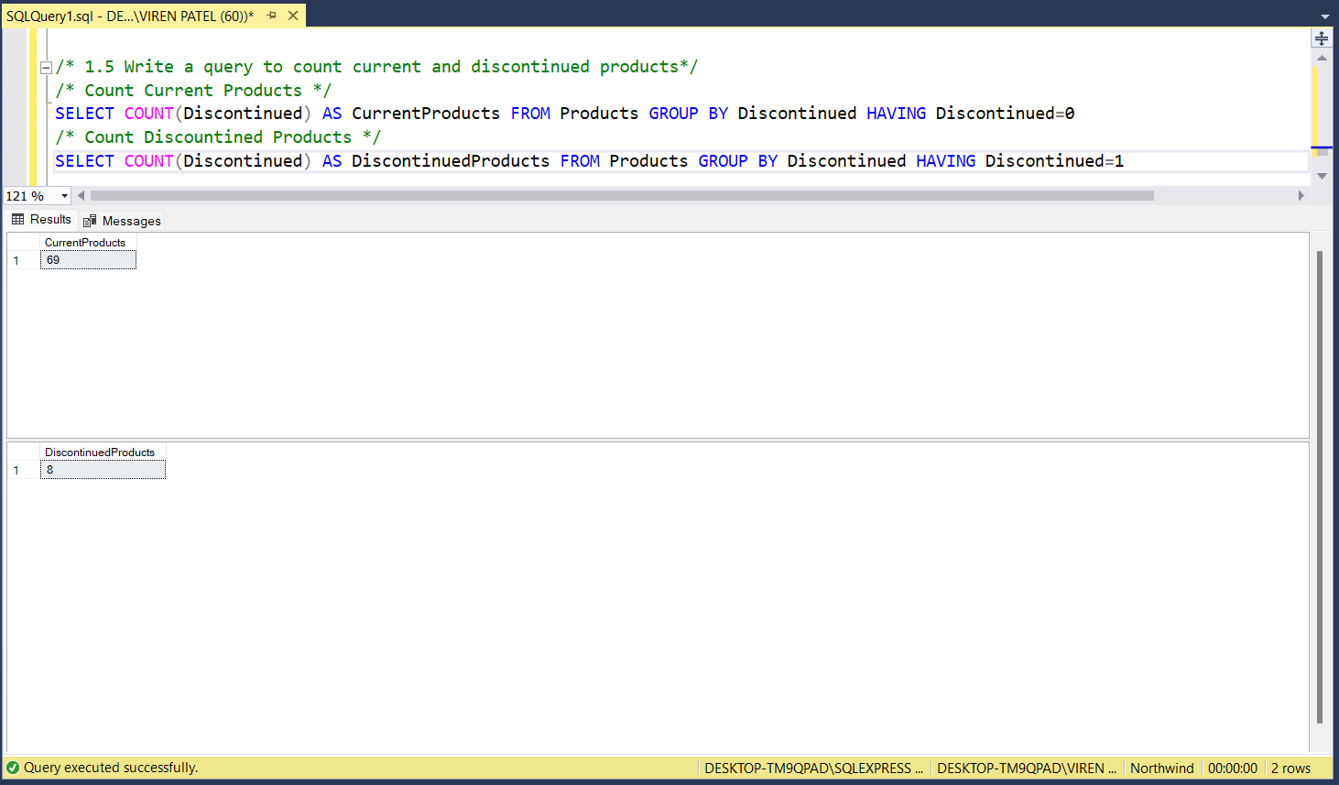

1. **Write a query to get Product list (name, units on order , units in stock) of stock is less than the quantity on order.**

**Query :** SELECT ProductName, UnitsOnOrder, UnitsInStock FROM Products WHERE UnitsInStock < UnitsOnOrder

